Pizza Sales Project (SQL Queries)

**Over-Viewing the Data**

select * from [dbo].[Pizza_Sales]

**KPI’s Requirement**

1. **Total Revenue**

Select Cast(sum(total_price) as Decimal (10,2)) As Total_Revenue From [dbo].[Pizza_Sales]

***OUTPUT***

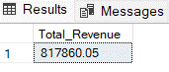

1. **Average Order Value**

Select Cast(SUM(total_price) / Count(Distinct order_id) as Decimal(10,2)) as Average_Revenue From Pizza_Sales

***OUTPUT***

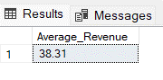

1. **Total Pizza Sold**

select Sum(quantity) as Total_Pizza_Sales

from [My Data Base]..Pizza_Sales

***OUTPUT***

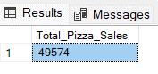

1. **Total Orders**

Select COUNT(Distinct order_id) As Total_Order

from [My Data Base]..Pizza_Sales

**OUTPUT**

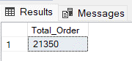

1. **Average Pizzas Per Order**

select Cast(Cast(sum(quantity) as decimal(10,2)) / Cast(COUNT(Distinct order_id) as Decimal(10,2)) as Decimal(10,2)) as Average_Pizza_Per_Order

**from Pizza_Sales**

**OUTPUT**

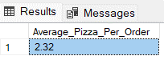

**Business Insights Report**

1. **Daily Trend For Total Orders**

select DATENAME(Dw,order_date) as Day, COUNT(Distinct order_id) As Total_order from Pizza_Sales Group By Datepart(Dw,order_date),DATENAME(Dw,order_date) order by Datepart(Dw,order_date)

**OUTPUT**

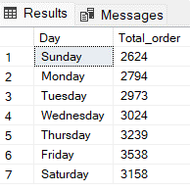

1. **Monthly Trend For Total Orders**

select DATENAME(MONTH,order_date) as Month, COUNT(Distinct order_id) As Total_order

from Pizza_Sales Group By Datepart(MONTH,order_date),DATENAME(MONTH,order_date)

order by Datepart(MONTH,order_date)

**OUTPUT**

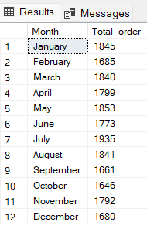

1. **Percentage of Sales by Pizza Category**

select pizza_category as Pizza_Category,CAST(SUM(total_price) as decimal(10,2)) as Total_Sales,

CAST(SUM(total_Price)*100/

(Select SUM(total_Price) From Pizza_Sales) as decimal(10,2)) as Percentage_By_Sales

from Pizza_Sales group by pizza_category

order by Percentage_By_Sales

**OUTPUT**

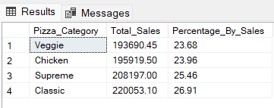

1. **Percentage of Sales by Pizza Size**

select pizza_size as Pizza_Size,CAST(SUM(total_price) as decimal(10,2)) as Total_Sales,

CAST(SUM(total_Price)*100/

(Select SUM(total_Price) From Pizza_Sales) as decimal(10,2)) as Percentage_By_Sales

from Pizza_Sales group by pizza_size

order by Percentage_By_Sales desc

**OUTPUT**

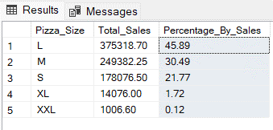

1. **Total Pizzas Sold by Pizza Category**

select pizza_category as Pizza_Category, SUM(quantity) as Total_Pizzas_Sold

from Pizza_Sales group by pizza_category

order by Total_Pizzas_Sold Desc

**OUTPUT**

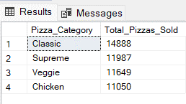

1. **Top Five Pizza by Total Revenue**

select Top 5 pizza_name as Pizza_Name,CAST(SUM(total_price) as decimal(10,2)) as Total_Revenue

from Pizza_Sales

group by pizza_name

order by Total_Revenue Desc

**OUTPUT**

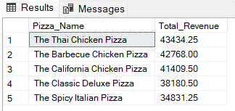

**Top Five Pizza by Total Quantity**

select Top 5 pizza_name as Pizza_Name,SUM(quantity) as Total_Quantity

from Pizza_Sales

group by pizza_name

order by Total_Quantity desc

**OUTPUT**

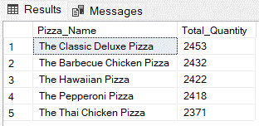

**Top Five Pizza by Total Orders**

select Top 5 pizza_name as Pizza_Name, Count(Distinct order_id) as Total_Order

from Pizza_Sales

group by pizza_name

order by Total_Order desc

**OUTPUT**

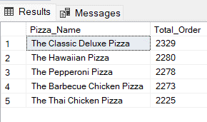

1. **Bottom Five Pizza by Total Revenue**

select TOP 5 pizza_name as Pizza_Name,CAST(SUM(total_price) as decimal(10,2)) as Total_Revenue

from Pizza_Sales

group by pizza_name

order by Total_Revenue

**OUTPUT**

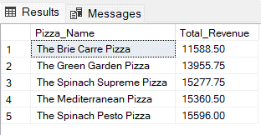

**Bottom Five Pizza by Total Quantity**

select Top 5 pizza_name as Pizza_Name,SUM(quantity) as Total_Quantity

from Pizza_Sales

group by pizza_name

order by Total_Quantity

**OUTPUT**

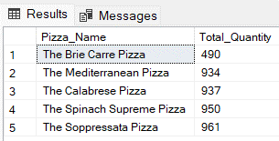

**Bottom Five Pizza by Total Orders**

select Top 5 pizza_name as Pizza_Name, Count(Distinct order_id) as Total_Order

from Pizza_Sales

group by pizza_name

order by Total_Order

**OUTPUT**

